FactoryGrid Development Plan (Node.js)
Oct 10, 2026 · @Praveen Kumar
FactoryGrid moves from a demo frontend on mock data to a production platform built on a Node.js and TypeScript backend, in 8 phases. Backend APIs come first, each one defined by an OpenAPI contract, and the frontend is wired to them one phase behind. Frontend and backend share one language, TypeScript, and one set of generated API types.

Overview
FactoryGrid is a B2B pharmaceutical manufacturing marketplace. Buyers (PCD, TPM, distributor, hospital, export, wholesaler) raise RFQs, manufacturers quote, and the platform turns accepted quotes into orders, invoices, payments and shipments. Admin, compliance, sales, accounts and Factory Buddy (field agent) roles govern each step.
The repo today:
Area | State today | What it means for the plan
Frontend (frontend/) | React 19 + Vite 8 + Tailwind 4. About 72 module screens across buyer, manufacturer and admin flows | The UI and the domain model in src/types/index.ts are the requirements source. Screens read mock data and local state, not APIs
IAM service (backend/services/iam-service) | Java 17 / Spring Boot 3.3, PostgreSQL, Flyway. Login, refresh, logout, /me, buyer and manufacturer registration, 8 roles, JWT | Ported to Node.js in Phase 1, keeping the same endpoints, database schema and password hashes. The Java tests serve as the spec
Infrastructure (backend/infrastructure) | api-gateway, config-server, eureka-server folders reserved, empty | Gateway built in Phase 0. Config server and Eureka are Spring tools and are not needed on Node.js
Integrations | Razorpay, GST verification (Message Central, API Sathi), Blue Dart, Delhivery, AI compliance check: all called from the browser, demo mode | Every one moves behind a backend service. The Razorpay key secret is read from a VITE_ variable today, which ships it inside the public bundle

What changes from the Java version of this plan
Topic | Java plan | Node.js plan
Language and framework | Java 17, Spring Boot 3 | TypeScript on Node.js 24 LTS, NestJS
Existing IAM service | Extended in place | Ported to NestJS in Phase 1, Java version retired after parity tests pass
Config and discovery | Spring Cloud Config + Eureka | Environment variables + secret manager; service names resolved by Docker / Kubernetes DNS
Repo layout | One Maven project per service | One pnpm + Nx monorepo for all services and shared libraries
Shared types | Frontend and backend types kept in sync by hand | Both generated from the same OpenAPI contracts
Timeline | About 30 weeks | About 31 weeks (one extra week for the IAM port)
Scope of this plan: service boundaries, Node.js stack, API-first phases, third-party integrations, the tech stack decision, the frontend migration, separate mobile apps, team setup and timeline. Sprint tickets come from each phase's API contract.

Target architecture
TypeScript microservices on NestJS behind one Kong gateway, each with its own PostgreSQL database, coordinated by RabbitMQ events rather than shared tables.
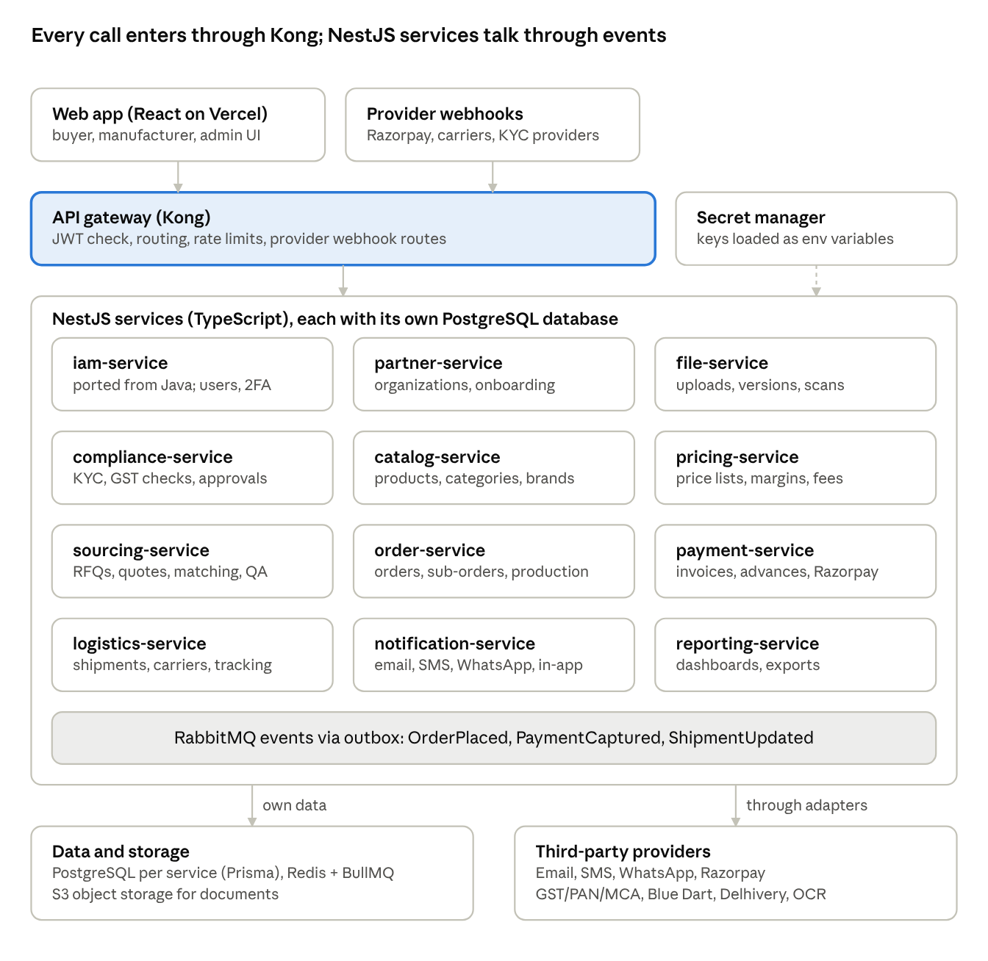
target architecture · Kong gateway, 12 NestJS services, RabbitMQ, providers
The browser and provider webhooks reach services only through the gateway. Services own their data and call third parties only through adapters (see Third-party integrations). There is no config server or service registry: settings come from environment variables, and services find each other by name through Docker or Kubernetes DNS.

Node.js technology stack
Every service is a NestJS application written in TypeScript. NestJS gives the team one structure for every service: modules, controllers, guards and dependency injection. It also has built-in support for OpenAPI and message queues.
Layer | Choice | Why
Runtime | Node.js 24 LTS (same version Vercel uses for the frontend) | Long-term support; one runtime across the repo
Language | TypeScript, strict mode | Same language as the frontend; contract types shared
Framework | NestJS on the Fastify adapter | Consistent structure for many services; Fastify is faster than Express
API docs | @nestjs/swagger, served at /docs and /docs-json per service | Replaces Springdoc. Contract tests compare it with the frozen spec
Validation | class-validator + class-transformer DTOs | Works with the Swagger decorators; field-level errors in the standard error format
Database | PostgreSQL 17, one database per service | Same as today
Data access and migrations | Prisma ORM + Prisma Migrate | Typed queries, readable schema file, versioned SQL migrations (replaces Flyway)
Auth | @nestjs/jwt + Passport JWT strategy, bcrypt for passwords, otplib for TOTP 2FA | bcrypt reads the existing BCrypt hashes, so current users keep their passwords
Messaging | RabbitMQ through @nestjs/microservices, with an outbox table per service | Reliable events between services; Kafka later only if volume demands it
Background jobs | BullMQ on Redis | Retries for emails, webhooks, provider calls, scheduled jobs such as overdue invoices
Cache and rate limits | Redis, @nestjs/throttler | Sessions, catalog and price caching
HTTP calls to providers | undici / axios with cockatiel for retry, timeout and circuit breaker | Replaces Resilience4j
Logging and tracing | pino JSON logs, OpenTelemetry SDK for Node, prom-client metrics | Request ID through every service
Testing | Jest + Supertest, Testcontainers for Node (real PostgreSQL, Redis, RabbitMQ) | Same test pyramid as the Java service
Monorepo | pnpm workspaces + Nx | One install, shared libraries, only changed services rebuild in CI
Container | Docker image per service on node:24-alpine, multi-stage build | Small, consistent images
Gateway | Kong (open source) in declarative mode | JWT checks, routing, rate limits and webhook routes without custom code

Tech stack decision
Decision: Node.js (NestJS + TypeScript) for the backend, PostgreSQL for data, React for the web app and React Native for the mobile apps. Choose .NET instead only if the team or hiring plan is mainly C#.

Why Node.js
- One language across backend, web and mobile. The web app is already React and TypeScript. With Node.js on the backend and React Native on mobile, every developer works in TypeScript, and API types are generated once from the contracts for all three.
- Scale depends on architecture, not language. A B2B pharma marketplace serves thousands to tens of thousands of business users. At that size, limits come from database queries, caching and slow work done inside requests. This plan handles those with stateless services that run as several copies, Redis caching, RabbitMQ events and BullMQ background workers. Node.js, .NET and Java all scale well on that design.
- Mobile needs a well-designed API, not a particular backend language. The API-first plan already provides that.

Options compared
 | Node.js (NestJS) | .NET (ASP.NET Core) | Java (Spring Boot)
Raw performance | Good; heavy computing goes to background workers | Excellent, among the fastest | Very good
Code shared with web and mobile | Yes: types, API client, validation | No | No
One language for the whole team | Yes | No (C# plus TypeScript) | No (Java plus TypeScript)
Heavy computing (PDFs, reports, OCR) | As background jobs | Strong | Strong
Enterprise and compliance reputation | Good | Very strong (Microsoft, Azure) | Very strong
Hiring in India | Plentiful | Plentiful | Plentiful
Fit with existing code | Login service needs porting | Login service needs porting | Login service already built
Risk from third-party packages | Higher; needs strict package rules | Lower; standard library covers most needs | Lower

When .NET is the better choice
- Current developers are mostly C#. Team skill matters more than anything in the table above.
- Hosting will be on Azure, or large enterprise or government buyers expect a Microsoft stack.
- The backend will do a lot of heavy computing, such as large reconciliations or analytics.
If .NET is chosen, the plan's structure stays the same and only the tools change:
Node.js piece | .NET equivalent
NestJS | ASP.NET Core
Prisma | Entity Framework Core
RabbitMQ with outbox | MassTransit (RabbitMQ, with outbox)
BullMQ | Hangfire
Kong gateway | YARP or Kong
Jest + Supertest | xUnit + WebApplicationFactory

Start with fewer deployable apps
The service catalog below defines 12 services as boundaries of ownership and data. Until team size is set, deploy them as 4 apps, each made of NestJS modules with those same boundaries:
Deployable app | Modules inside
identity-partners | iam, partner, file, compliance
catalog-sourcing | catalog, pricing, sourcing
orders-payments | order, payment, logistics
notifications-reporting | notification, reporting
Each module keeps its own database schema and talks to other modules only through their APIs or events. A module moves into its own service when its load or its team grows, with little code change. This avoids running 12 services before the team or traffic needs them.

Service catalog
Twelve NestJS business services behind one Kong gateway. Boundaries follow the frontend modules, so each team owns a full slice: its tables, its APIs and its screens. Split a service further only when load or team size demands it.
Service (backend/apps/...) | Owns (data and rules) | Key API resources (/api/v1/...) | Frontend modules it serves | Phase
api-gateway (Kong config) | Routing, JWT check, rate limits, CORS, request IDs, webhook routes | All external traffic | All | 0
iam-service (ported from Java) | Users, roles, permissions, sessions, 2FA, password reset | auth, users, roles, me/security | Login, Security2FA, BuyerSecuritySettings, Settings | 1
partner-service | Organizations (buyers, customers, manufacturers), onboarding, profiles, capabilities, facilities, segments, ratings | organizations, buyers, manufacturers, onboarding, customer-segments | Buyer/ManufacturerOnboardingWizard, ManufacturerProfilePage, ManufacturerMaster, Customer, CustomerSegmentMaster, Profile | 2
file-service | Uploads, document versions, presigned URLs, virus scan | files, documents/{id}/versions | All upload screens | 2
compliance-service | Verification cases (customer, manufacturer, brand, trademark), GST/PAN/drug licence checks, AI document checks, approval workflow, audit log | verifications, compliance-cases, approvals, audit-logs | CustomerVerification, ManufacturerVerification, Brand/TrademarkVerification, Compliance, Admin*Verification, AdminApproval | 2
catalog-service | Products, categories (3 levels), brands, attributes, UoM, tax, product-manufacturer mapping | products, categories, brands, attributes, uoms, tax-rules, product-manufacturers | ProductCatalog, CategoryMaster, BrandMaster, AttributeMaster, ProductUom, ProductTax, ProductManufacturerMapping, Buyer/ManufacturerProductCatalog | 3
pricing-service | Price lists, margin rules by scope, platform fees, direct-order eligibility | price-lists, margin-rules, platform-fees, price-quotes (calculate) | ProductPrice, MarginEngine | 3
sourcing-service | RFQs, distribution to manufacturers, AI matching, manufacturer quotes, quote comparison, customer quotations, sales qualification, QA threads | rfqs, rfqs/{id}/distributions, manufacturer-quotes, customer-quotes, qa-requests | RFQ, Quote, AIMatching, ManufacturerAssignedRFQs, ManufacturerQuoteSubmissions, BuyerQuoteComparison, CustomerQuotation, SalesQualification, BuyerQa, AdminRfq/QuoteMonitor | 4
order-service | Master orders, splitting into sub-orders, admin approval, production execution, status history | orders, orders/{id}/sub-orders, production-runs | Order, MasterOrderSplitting, ManufacturerSubOrder, ProductionExecution, BuyerOrderTracking, AdminOrderMonitor, ManufacturerOrderHistory | 5
payment-service | Proforma and tax invoices, advance payments, payments, refunds, ledger, Razorpay | invoices, proforma-invoices, advance-payments, payments, webhooks/razorpay | Invoice, BuyerAdvancePayments, Accounts | 5
logistics-service | Shipments, carrier booking, tracking, temperature logs | shipments, shipments/{id}/tracking, webhooks/{carrier} | Shipment, BuyerOrderTracking | 6
notification-service | Email, SMS, WhatsApp, in-app notifications, templates, user preferences, Factory Buddy messages | notifications, templates, preferences, conversations | Notifications, FactoryBuddyCommunicationDesk | 1 (email only), 6 (full)
reporting-service | Read models built from events, dashboards, exports | reports, dashboards/{role} | Dashboards, Analytics, Reports, AdminAnalytics, ManufacturerAnalytics | 7
Rules every service follows
- One PostgreSQL database per service, with its own Prisma schema. No service reads another service's tables.
- Synchronous HTTP calls between services only for reads that need an answer now, such as pricing calculating a quote. State changes publish RabbitMQ events.
- Each service exposes its OpenAPI spec at /docs-json. The gateway serves a combined Swagger UI.
- Integration credentials live in the owning service's secret store, never in the frontend. IntegrationsSettingsModule becomes an admin screen that calls the backend.
- In-app notifications and live tracking reach the browser through Server-Sent Events from notification-service. WebSockets are used only if two-way chat needs them.

Phase plan: API first
Every phase starts with a frozen API contract and ends with deployed, tested endpoints. The order follows the business flow: you cannot quote without a catalog, and you cannot order without a quote.

How each API is built (contract-first loop)
- Backend lead writes the OpenAPI 3 spec for the phase (contracts/<service>.yaml) from the matching types in frontend/src/types/index.ts.
- Frontend lead and product owner review it. Contract is frozen once both approve the pull request.
- CI generates TypeScript types from the spec for both sides (openapi-typescript) and publishes a mock server (Prism), so frontend work can start at once.
- Backend implements the NestJS service: Prisma schema and migration, module, DTOs, controller, service, events.
- Contract tests in CI fail the build if the service's generated /docs-json differs from the frozen spec.
- Deployed to staging, then the frontend switches that module from mock to live API.

Phases
Phase 0: Foundations
- Monorepo: pnpm workspaces + Nx under backend/, with apps/ for services and libs/ for shared code. A NestJS service generator so a new service starts from the same template.
- API standards doc: /api/v1 versioning, the existing ApiResponse / ErrorResponse shapes kept as the standard envelope (the frontend already reads them), pagination (page, size, sort), filtering, Idempotency-Key header on POSTs that create money or orders, UTC ISO-8601 dates, money as integer paise + currency.
- Shared libraries: libs/auth (JWT guard, roles decorator), libs/errors (exception filter producing ErrorResponse), libs/prisma (base client, audit fields), libs/outbox (outbox table + RabbitMQ relay), libs/testing (Testcontainers setup).
- Kong gateway in declarative config (backend/gateway/kong.yaml). Delete the config-server and eureka-server folders; they are not needed on Node.js.
- Local stack in docker-compose.yml: PostgreSQL, Redis, RabbitMQ, MinIO (S3-compatible), Mailpit (catches emails), Kong.
- CI on GitHub Actions: nx affected lint, type-check, unit and integration tests, OpenAPI lint, Docker image per changed service.
- Observability: pino JSON logs with request ID, OpenTelemetry tracing, Prometheus metrics endpoint per service.
- Exit gate: a new service generated from the template runs behind Kong with auth in under a day.
Phase 1: Identity (port IAM to Node.js, then extend)
- Port first, with no behaviour change: same endpoints under /api/v1/auth (login, refresh, logout, me, register/buyer, register/manufacturer), same JSON shapes, same PostgreSQL tables. Run prisma db pull on the existing schema and baseline it so Prisma takes over from Flyway without data loss.
- Rewrite the Java tests (IamSecurityAndAuthTest, UserRepositoryTest) as Jest + Supertest tests and make them pass. Then point the frontend at the Node.js service and retire the Java one.
- Extend: link users to organizations, user admin APIs (invite, deactivate, assign roles), permission checks per endpoint, TOTP 2FA (move totpUtils.ts logic server-side), password reset and email verification, login audit.
- notification-service v1: transactional email only (verify email, reset password, invites), templates in MJML or Handlebars.
- Exit gate: all 8 roles can register or be invited, verify email, log in with 2FA and reset password through the gateway; existing users log in with their current passwords.
Phase 2: Partners, files, compliance
- partner-service: buyer and manufacturer organizations, onboarding wizard steps saved as drafts, profiles, capabilities, facilities, certifications, customer segments.
- file-service: presigned S3 upload, document versions, expiry dates, virus scan (ClamAV) as a BullMQ job.
- compliance-service: verification cases, GST/PAN/MCA checks through providers, drug licence checks, AI document review (human makes the final decision), admin approval queue, audit log.
- Exit gate: a buyer and a manufacturer can onboard, upload documents and be approved or rejected by an admin, with every step audited.
Phase 3: Catalog and pricing
- catalog-service: products, 3-level categories, brands, attributes per category, UoM, tax rules, product-manufacturer mapping, CSV/Excel bulk import as a BullMQ job.
- pricing-service: price lists by customer segment, margin rules by scope (manufacturer, category, product, default), platform fees, price calculation API. Money maths uses integers or decimal.js, never JavaScript floats.
- Exit gate: buyers search a catalog with live prices that match the margin rules for their segment.
Phase 4: Sourcing (RFQ to quote)
- sourcing-service: RFQ create and submit, distribution to matched manufacturers, manufacturer quotes, buyer quote comparison, customer quotation with margins applied, sales qualification, QA threads.
- AI matching as a scoring endpoint (rules first, model later).
- Exit gate: an RFQ goes from draft to an accepted quote end to end, with emails at each hand-off.
Phase 5: Orders and payments
- order-service: master order from accepted quote, admin approval, split into sub-orders per manufacturer, production status updates.
- payment-service: proforma invoice, advance payment (percentage or fixed), Razorpay order creation and webhook-verified capture, tax invoice (PDF), partial payments, overdue tracking as a scheduled job, refunds.
- Exit gate: an accepted quote becomes a paid, split order in Razorpay test mode, with the ledger reconciled.
Phase 6: Logistics and full notifications
- logistics-service: shipment creation, Blue Dart and Delhivery booking and tracking through webhooks, temperature logs, delivery confirmation and goods receipt.
- notification-service v2: SMS, WhatsApp, in-app notifications over Server-Sent Events, user preferences, Factory Buddy conversations.
- Exit gate: a sub-order ships, tracking updates reach the buyer screen and phone, and delivery closes the sub-order.
Phase 7: Reporting and hardening
- reporting-service: read models built from events, role dashboards, CSV and PDF exports.
- Load tests (k6) on the gateway and order/payment paths, security review (OWASP ASVS level 2, pnpm audit and dependency scanning in CI), backups and restore drill, runbooks.
- Exit gate: production go-live checklist signed off.

Third-party integrations
Every third-party call goes through the backend service that owns the data, behind an adapter interface. A provider can then be swapped or added as needed without touching business logic or the frontend.
Need | Provider (in code today, or to choose) | Node.js library | Owning service | Phase
Transactional email | To choose: Amazon SES, SendGrid or similar. Mailpit locally | @aws-sdk/client-sesv2 or @sendgrid/mail; nodemailer for local | notification-service | 1
SMS and WhatsApp | To choose: an India-ready SMS/WhatsApp gateway | Provider SDK or REST via undici | notification-service | 6
Payments | Razorpay (frontend demo today) | razorpay (official SDK) | payment-service | 5
GST, PAN, MCA verification | Message Central / eKYCNow, API Sathi GST Verify (frontend connectors today) | REST via undici; move the existing connector classes server-side | compliance-service | 2
Document OCR / AI review | To choose (demo stub today in aiComplianceService.ts) | Provider SDK | compliance-service | 2
Logistics | Blue Dart, Delhivery (frontend connectors today) | REST via undici; move BlueDartConnector.ts and DelhiveryConnector.ts server-side | logistics-service | 6
File storage | S3 or S3-compatible (MinIO locally) | @aws-sdk/client-s3, @aws-sdk/s3-request-presigner | file-service | 2
PDF invoices | Generated in-house | pdfmake or Puppeteer | payment-service | 5
Data sourcing (product master, manufacturer data, regulatory lists) | Case by case: CSV/Excel import first, provider APIs when a source is chosen | exceljs, csv-parse | catalog-service or partner-service | 3 onward
The frontend connector classes are already TypeScript, so much of their request-building logic can move to the backend adapters with little change.

Integration pattern (same for every provider)
- Port and adapter. The service defines a TypeScript interface (PaymentGateway, GstVerifier, CarrierClient, EmailSender). Each provider is one injectable NestJS class. Choosing a provider is configuration, not code.
- Secrets server-side only. Keys live in a secret manager and reach the service as environment variables, checked at startup with @nestjs/config and a validation schema. Sandbox and production credentials are kept apart, as the current connector screens already model.
- Outbound calls are resilient. Timeouts, retries with backoff and circuit breakers via cockatiel. Each call is logged with request ID, provider, latency and outcome, never with secrets or full personal data.
- Inbound webhooks are verified. Kong routes /webhooks/{provider} to the owning service. The service reads the raw request body, checks the signature, stores the raw event, and processes it idempotently by event ID.
- Side effects go through the outbox and BullMQ. A business change and its event are saved in one Prisma transaction. The relay publishes to RabbitMQ; slow or retryable work (emails, provider calls) runs as BullMQ jobs, so nothing is lost or sent twice.
- Each adapter has a fake. Tests and local runs use a fake adapter. One contract test per adapter runs against the provider's sandbox nightly.

Payment flow (Razorpay)
- Frontend asks payment-service for a payment on an invoice or advance.
- payment-service creates the Razorpay order server-side with the razorpay SDK and returns only the order ID and the public key ID.
- Frontend opens Razorpay Checkout.
- Razorpay calls the payment.captured webhook. payment-service verifies the signature with the webhook secret (crypto.createHmac), marks the payment paid and publishes PaymentCaptured.
- order-service and notification-service react to the event. The frontend reads the result from the API, not from the checkout callback.
Fix now, before any live key exists: remove VITE_RAZORPAY_KEY_SECRET and verifyRazorpaySignature from frontend/src/services/razorpayService.ts. Any VITE_ variable is bundled into public JavaScript. The same applies to GST provider API keys entered in the browser.

Phase plan: frontend
The screens already exist, so frontend work means replacing mock data with live APIs, one domain at a time, one phase behind the backend. Frontend phase Fn starts when backend phase n has a frozen contract and a mock server. It finishes when that phase's APIs are live on staging.
Today all data sits in one 5,507-line AppContext.tsx (57 useState hooks) seeded from a 7,132-line mockData.ts, and the largest modules run to about 3,900 lines. That is the main thing to unwind.

F0: Frontend foundations (alongside backend Phase 0)
- Move frontend/ into the same pnpm workspace as the backend, so it imports the generated contract types package (@factorygrid/contracts) directly. A contract change then breaks the frontend build, not production.
- Server state with TanStack Query: caching, loading and error states, retries, invalidation after changes.
- One HTTP layer (openapi-fetch on the generated types): base URL from VITE_API_BASE_URL (the Kong gateway, not localhost:8081), bearer token, automatic refresh on 401, request ID header, standard error toasts from ErrorResponse.
- Mock Service Worker (MSW) handlers generated from the same specs, switchable per module, so screens work before the backend does.
- Route guards by role from the /me response. Remove hard-coded role switching.
- Testing: Vitest + Testing Library for components, Playwright for each phase's exit-gate flow.
- Remove all secrets and provider keys from frontend code and VITE_ variables.
- Update vercel.json install and build commands for the workspace (pnpm install --frozen-lockfile, pnpm --filter frontend build).

Per-phase frontend work
Phase | Modules switched to live APIs | Done when
F1 Identity | LoginPage, Security2FA, BuyerSecuritySettings, Settings, user admin screens | Login, 2FA, reset and invite work against the Node.js IAM through Kong; auth slice removed from AppContext
F2 Partners and compliance | Buyer/ManufacturerOnboardingWizard, Profile, ManufacturerProfilePage, Customer, CustomerVerification, ManufacturerVerification, Brand/TrademarkVerification, all Admin*Verification and monitors, AdminApproval, Compliance | Onboarding to approval runs with real uploads; partner and compliance mock data deleted
F3 Catalog and pricing | ProductCatalog, CategoryMaster, BrandMaster, AttributeMaster, ProductUom, ProductTax, ProductPrice, ProductManufacturerMapping, MarginEngine, CustomerSegmentMaster, Buyer/ManufacturerProductCatalog | Catalog lists are paged and filtered on the server, prices come from pricing-service
F4 Sourcing | RFQ, Quote, AIMatching, ManufacturerAssignedRFQs, ManufacturerQuoteSubmissions, BuyerQuoteComparison, CustomerQuotation, SalesQualification, BuyerQa, RaiseQaModal, AdminQaGovernance, AdminRfq/QuoteMonitor | RFQ to accepted quote passes the Playwright flow
F5 Orders and payments | Order, MasterOrderSplitting, ManufacturerSubOrder, ProductionExecution, BuyerOrderTracking, AdminOrderMonitor, ManufacturerOrderHistory, Invoice, BuyerAdvancePayments, Accounts | Razorpay test payment updates order status through the webhook; razorpayService only opens checkout
F6 Logistics and notifications | Shipment, Notifications, FactoryBuddyCommunicationDesk, IntegrationsSettings (admin, backend-stored) | Tracking and in-app notifications arrive over Server-Sent Events without a page reload
F7 Reporting | Dashboards, Analytics, Reports, AdminAnalytics, ManufacturerAnalytics, ManufacturerDashboard | Dashboards read reporting-service; mockData.ts and the data parts of AppContext are deleted

Rules while migrating each module
- Replace the module's AppContext reads with query hooks in src/api/<domain>/ (for example useRfqs, useSubmitQuote). Keep AppContext only for UI state such as theme and sidebar.
- Retire hand-written types in src/types/index.ts as each domain moves to the generated contract types.
- Split modules over about 800 lines into a page, sub-components and hooks while touching them, not as a separate rewrite.
- Every list has server-side paging, a loading state, an empty state and an error state.
- Forms validate on the client for speed, but the server's validation errors are the source of truth and are shown per field.

Mobile apps
The mobile apps are a separate product: their own repository, team, release cycle and app store listings, with no code shared with the web app. The only link is the backend API and its published contract types.

Separation from the web app
 | Web app | Mobile apps
Repository | factory_Grid (this repo) | New repo factorygrid-mobile
Team | Web developers in each workstream | Separate mobile team (suggested: 2 React Native developers, 1 QA)
UI code | React + Tailwind | React Native screens built for phones; no shared components
Release | Vercel, on every merge | App Store and Play Store builds through Expo EAS, plus over-the-air updates for JavaScript-only fixes
Link to backend | Same Kong gateway and APIs | Same Kong gateway and APIs
Shared code | None with mobile | Only @factorygrid/contracts, a versioned package of generated API types published to a private npm registry (GitHub Packages)
The mobile app pins a version of the contracts package and upgrades it on its own schedule, so web releases never break the phone apps.

Which apps
- FactoryGrid Buyer: login with 2FA and biometrics, catalog browsing, create RFQs, compare quotes, accept quotes, pay advances and invoices, track orders and shipments, notifications.
- FactoryGrid Partner (manufacturers and Factory Buddy agents, by role): assigned RFQs, submit quotes, sub-orders and production updates, photograph and upload documents, Factory Buddy visit notes that work offline and sync later.
- Admin, compliance, sales and accounts stay on the web app.

Mobile stack
Need | Choice
Framework | React Native with Expo, Expo Router for navigation
API calls and caching | openapi-fetch on @factorygrid/contracts, TanStack Query
Secure login storage | expo-secure-store for refresh tokens, expo-local-authentication for biometric unlock
Push notifications | expo-notifications (FCM on Android, APNs on iOS)
Camera and documents | expo-camera, expo-image-picker, expo-document-picker, uploading straight to S3 with presigned URLs
Offline (Factory Buddy) | expo-sqlite for drafts and a sync queue
Payments | Razorpay React Native SDK, same server-side flow as the web
Builds and store release | EAS Build, EAS Submit, EAS Update
Crash reporting | Sentry
Testing | Jest for logic, Maestro for end-to-end flows

What the backend adds for mobile
These are added to the backend phases listed, owned by the backend workstreams, not the mobile team:
- Device registration in notification-service: POST /api/v1/devices stores push tokens per user and device (Phase 6).
- Push sending through Expo push or FCM/APNs, using the same notification events as email and SMS (Phase 6).
- Version support: old API versions stay live for at least 6 months after a new one, because phone users update late. GET /api/v1/app-config returns the minimum supported app version so old apps can ask users to update (Phase 4).
- Per-device sessions: refresh tokens tied to a device, so a lost phone can be signed out from the web (Phase 1).
- Sync endpoints with updatedSince filters for offline Factory Buddy data (Phase 6).

Mobile phases
Mobile starts once the sourcing APIs (Phase 4) are frozen, so it is not reworked as early APIs change.
Phase | Weeks (proposed) | Delivers | Done when
M0 Setup | W17-18 | Repo, Expo project, CI with EAS, mobile design basics, login and 2FA against the Node.js IAM | A test build installs on both platforms and logs in
M1 Buyer app | W19-25 | Catalog, RFQs, quote comparison, order tracking, push notifications | Buyer runs RFQ to accepted quote on a phone
M2 Partner app | W24-30 | Assigned RFQs, quotes, sub-orders, production updates, document photos, offline Factory Buddy notes | Manufacturer quotes and updates production; a Factory Buddy visit syncs after being offline
M3 Payments and launch | W29-34 | Razorpay in-app payments, TestFlight and Play internal testing, store review | Both apps approved and live in the stores
Mobile go-live lands about 3 weeks after the web go-live (week 31). That lets the web launch settle the APIs first.

Open decisions for mobile
- ☐ Two apps (Buyer, Partner) as recommended, or one app with role-based screens
- ☐ Minimum iOS and Android versions supported
- ☐ How much of the Factory Buddy flow must work fully offline

Team structure and ways of working
Four web and backend workstreams, plus a separate mobile team. Each workstream owns its services end to end, and from Phase 1 on each pairs backend developers with a frontend developer. Because both sides are TypeScript, developers can move between backend and frontend tasks within a stream. Team size is not set yet; the layout below assumes 2 to 3 backend developers and 1 frontend developer per stream.
Workstream | Owns | Starts
Platform | Monorepo and generators, Kong gateway, shared libraries, CI/CD, environments, observability, security review | Phase 0
Identity and partners | iam-service port and extension, partner-service, file-service, compliance-service, notification-service v1 | Phase 1
Catalog and sourcing | catalog-service, pricing-service, sourcing-service | Phase 3 (helps Identity and partners in Phase 2)
Orders and fulfilment | order-service, payment-service, logistics-service, notification-service v2, reporting-service | Phase 5 (writes Phase 5 contracts during Phase 4)
Mobile (separate team) | factorygrid-mobile repo: Buyer and Partner apps, store releases. Suggested 2 React Native developers and 1 QA. Consumes the API only; asks backend streams for mobile endpoints | Week 17 (M0), see Mobile apps
Once Phase 2 is under way, contracts for the next phase are written while the current one is being built. This keeps both backend and frontend busy.

Monorepo layout
pnpm-workspace.yaml workspace root (backend apps, libs, frontend)
nx.json
contracts/ <service>.yaml OpenAPI specs (source of truth)
backend/
apps/<name>-service/ one NestJS app per service, own prisma/schema.prisma
libs/auth libs/errors libs/prisma libs/outbox libs/testing
libs/contracts/ generated TypeScript types, published as @factorygrid/contracts
gateway/kong.yaml routes, JWT plugin, rate limits
frontend/ React app, imports @factorygrid/contracts
docker-compose.yml local stack
- Trunk-based: short feature branches, pull requests into main, at least one reviewer from the owning stream. Contract changes also need the frontend lead's review.
- Code style: ESLint + Prettier shared config across backend and frontend; TypeScript strict everywhere, no any in service code.
- Database changes only through Prisma migrations committed with the code. Never edit a migration that has already run in staging.
- Each service gets a fixed local port (iam 8081 as today, then 8082 upward) recorded in the README.
- Commit messages follow Conventional Commits, as the repo already does.

Definition of done (every story)
- Matches the frozen OpenAPI contract, and contract tests pass.
- Unit tests for business rules (Jest), integration tests with Testcontainers for database access and endpoints (Supertest).
- Role guard on every endpoint, with a test that a wrong role gets 403.
- Audit fields (created/updated by and at) on every table. Audit log entry for every approval, money or status change.
- Errors use the standard ErrorResponse, with no stack traces or secrets in responses or logs.
- Swagger decorators with descriptions and example payloads filled in.
- Deployed to staging by the pipeline. The frontend module using it works against staging with no mock.

Timeline, risks and open decisions
About 31 weeks to go-live with four staffed workstreams: one week more than the Java plan, for porting IAM in Phase 1. Phases overlap because separate streams own them, and each frontend phase starts once its API contract is frozen.
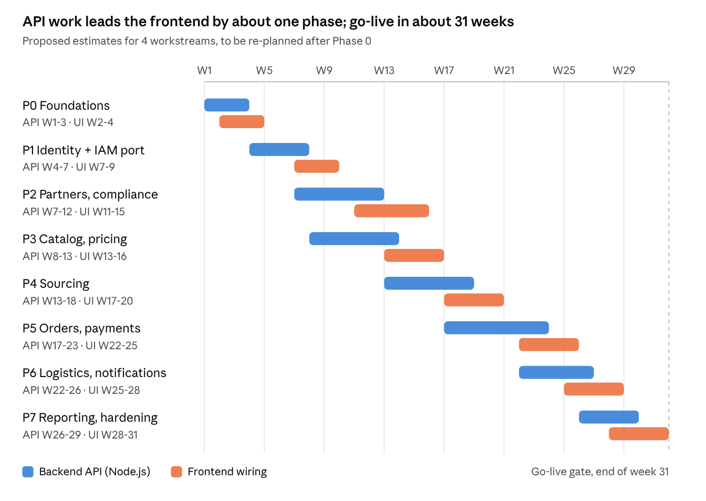
delivery roadmap · 8 phases, Node.js backend and frontend, in weeks
These are proposed estimates, not commitments. Re-estimate at the end of Phase 0, once the first contracts and the service template show real velocity.

Risks
Risk | Effect | Mitigation
IAM port changes behaviour | Existing users cannot log in, frontend auth breaks | Port with the same contract and schema first; Java tests rewritten as the acceptance suite; run both side by side in staging before switching
Contracts change late | Frontend rework, missed phase dates | Freeze per phase; changes after freeze need a new version or both leads' sign-off
AppContext and large modules are hard to untangle | F-phases run long | Migrate one domain at a time, delete its mock data at the end of each phase
Money calculated with JavaScript floats | Wrong invoice and margin totals | Integer paise everywhere, decimal.js for rates; unit tests on rounding
Node.js dependency sprawl and supply-chain risk | Security issues from third-party packages | Lockfile committed, pnpm audit and dependency scanning in CI, a short approved-library list
Provider onboarding (Razorpay live keys, KYC and carrier accounts) takes weeks | Phase 2, 5 and 6 blocked on paperwork | Start account applications in Phase 0; build against sandboxes and fakes
Cross-service order and payment consistency | Paid orders not released, or double charges | Outbox events, idempotency keys, a daily reconciliation job against Razorpay
Too many services for the team size | Slow delivery, heavy ops load | Start pricing inside catalog-service, or file inside partner-service, if streams are short-staffed; NestJS modules split out later with little change
Pharma regulatory data (drug licences, audit trails) | Failed audits | Audit log from Phase 2, data retention policy agreed with compliance before go-live

Open decisions
- ☐ Team size per workstream (sets the real timeline)
- ☐ Backend hosting: managed containers (for example AWS ECS) or Kubernetes
- ☐ Gateway: Kong (recommended) or a managed cloud API gateway
- ☐ ORM: Prisma (recommended) or Drizzle, confirmed after the IAM port
- ☐ Email provider, and SMS/WhatsApp gateway
- ☐ OCR / AI provider for document review
- ☐ Which data sources to integrate first for product and manufacturer data
- ☐ Multi-tenancy rules: what a Factory Buddy or sales manager may see across organizations

